# SANJALIKA WATERPARK SLIDE’S DESCRIPTION WITH MORE FEATURES

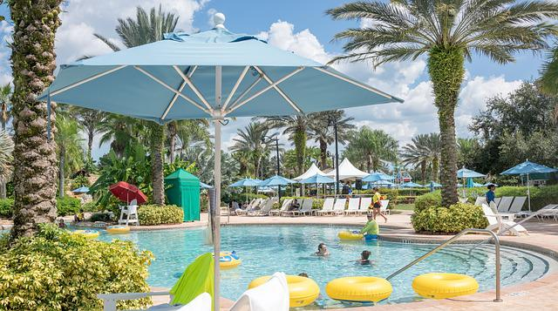

Figure sanjalika waterpark

Sanjalika Water Park is definitely an ultimate and out of the world source of entertainment. Decorated by mermaids, other statues, the Sanjalika Water park has largest cave and swimming pool area of modern technology a kind of place for thrills and fun. At Sanjalika Water park there is lot of water rides which are very exciting and thrilling.

In this document, you are gonna learn about more features of the slides with their information.

30M HIGH SPEED SLIDE

Water parks are amusement parks that consist of lots of slides, playgrounds, swimming pools and lots of other areas which are full of water but are covered with various roundabouts. Water parks are mostly the favorite place to visit for every child and a lot of families during the summer visit various water parks as well. There are a lot of famous water parks around the world, and here a few of those water parks would be discussed where one can enjoy a **water park picnic** with his family.

FEATURES OF THE 30M HIGH SPEED SLIDE

28m high-speed slide is undoubtedly one of the most exciting conventional water slide with a length of 20m-120m and a height of 7m-28m, which can be customized according to the actual needs of customers. From the highest point of the slide under the action of water and its own gravity, it can reach the fastest speed when sliding vertically to the lowest point, so that tourists can truly experience the thrilling vertical drop. At last, it decelerates under the action of friction and stops on the buffer section to complete the whole soul stirring journey. Whether you are experiencing it or standing in the distance, you will be overwhelmed by its thrill.   
  
Our water slide meets strict and demanding standards in terms of safety and durability. I believe you who pursue adventure will fall in love with it.

MORE FEATURES

|  |  |
| --- | --- |
| MATERIAL | FIBREGLASS |
| Width | 0.8m |
| Capacity | 01person |
| Platform height | 30m |
| Stretched length | 120m |
| Floor space | 15m*60m |
| Mats | No |
| Tubes | No |
| Rafts | No |
| Production method | RTM |

●  for one person playing  
● can design with waves  
● entrance of slide can be close  
● Use top material to make sure the safety and steady of water slide

30M HIGH SPEED SLIDE IMAGES

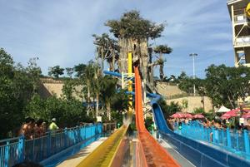

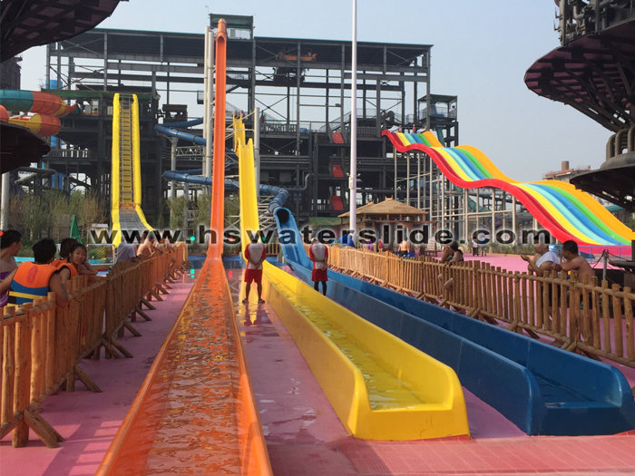

And many more images, customer feedback on such slides have always been good and keeps getting better.

Thank you!